Country: **MALAWI**

Year: **2017**

Number of Observations: **3729**

Number of Clusters: **4**

Number of variables used: **28**

Distance used: **Hamming**

**Summary of Top Cluster Configurations (ranked by ASW)**

| **Cluster #** | **ASW** | **Variable 1** | **Variable 2** | **Variable 3** | **Variable 4** |
| --- | --- | --- | --- | --- | --- |
| 1 | 0.9529 | hv206 | hv208 | hv209 | sh114i |
| 2 | 0.9500 | hv206 | hv208 | hv209 | hv227 |
| 3 | 0.9479 | hv206 | hv208 | hv209 | hv243a |
| 4 | 0.9464 | hv246b | sh114i | hv209 | hv243a |
| 5 | 0.9461 | hv246b | hv208 | hv209 | hv206 |
| 6 | 0.9458 | hv246b | hv206 | hv209 | hv243a |
| 7 | 0.9450 | hv246b | hv227 | hv209 | hv243a |
| 8 | 0.9447 | hv246b | hv208 | hv209 | sh114i |
| 9 | 0.9445 | hv246b | hv208 | hv209 | hv243a |
| 10 | 0.9444 | hv246b | sh114i | hv209 | hv206 |

**Distributions of ASW values in all clusters in Malawi**

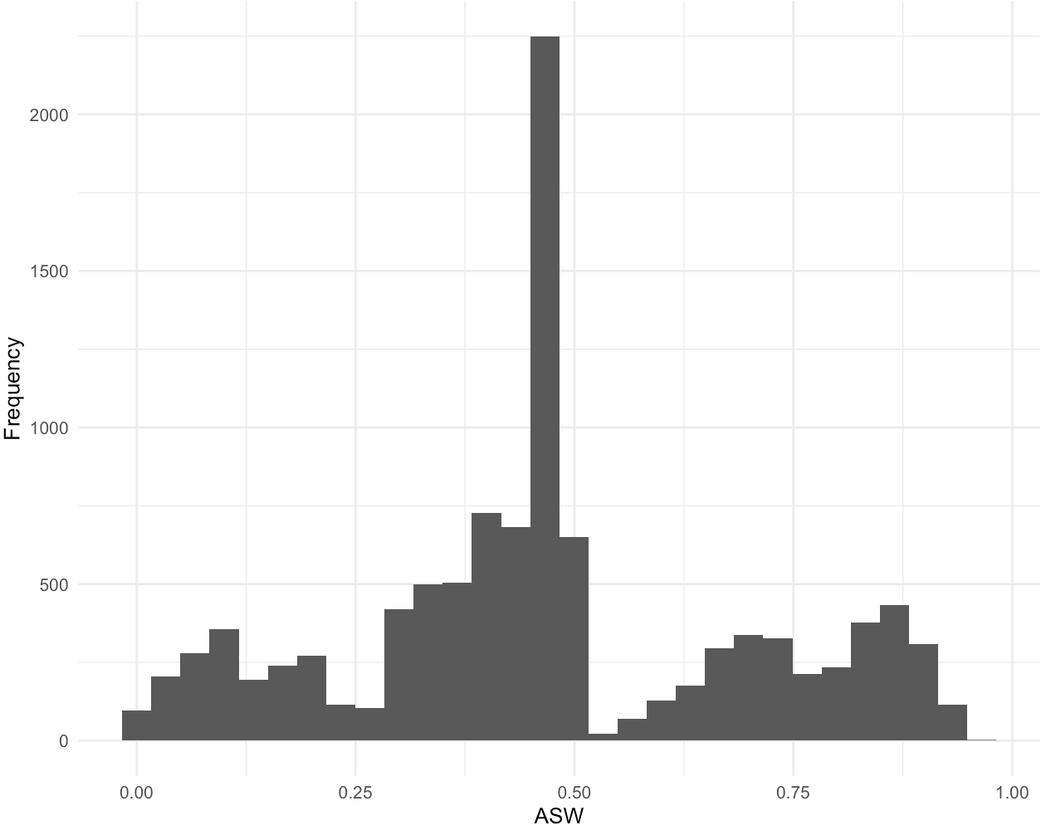

**Summary of variable distributions in top clusters**

Currently our method is choosing five distinct clusters of individuals within each cluster variable configuration. Here are the medioids for each of these five clusters:

**Cluster #1 Configuration**

| **Node** | **hv206** | **hv208** | **hv209** | **sh114i** | **Proportion** |
| --- | --- | --- | --- | --- | --- |
| 1 | 1 | 1 | 1 | 1 | 10.99% |
| 1 | 0 | 1 | 1 | 1 |
| 1 | 1 | 1 | 1 | 0 |
| 1 | 1 | 0 | 1 | 1 |
| 2 | 1 | 0 | 1 | 1 | 4.83% |
| 3 | 0 | 0 | 0 | 0 | 52.27% |
| 3 | 0 | 1 | 0 | 0 |
| 3 | 1 | 0 | 0 | 0 |
| 3 | 1 | 0 | 1 | 0 |
| 3 | 0 | 1 | 1 | 0 |
| 4 | 1 | 1 | 0 | 1 | 10.30% |
| 4 | 0 | 1 | 0 | 1 |
| 4 | 1 | 1 | 0 | 0 |
| 5 | 0 | 0 | 0 | 1 | 21.61% |
| 5 | 0 | 0 | 1 | 1 |

**Cluster #2 Configuration**

| **Node** | **hv206** | **hv208** | **hv209** | **hv227** | **Proportion** |
| --- | --- | --- | --- | --- | --- |
| 1 | 0 | 0 | 0 | 0 | 13.06% |
| 1 | 0 | 1 | 0 | 0 |
| 1 | 1 | 0 | 0 | 0 |
| 2 | 1 | 1 | 1 | 1 | 11.08% |
| 2 | 0 | 1 | 1 | 1 |
| 2 | 1 | 0 | 1 | 1 |
| 2 | 1 | 1 | 1 | 0 |
| 2 | 0 | 1 | 1 | 0 |
| 3 | 1 | 1 | 0 | 1 | 8.80% |
| 3 | 1 | 1 | 0 | 0 |
| 4 | 0 | 0 | 0 | 1 | 62.08% |
| 4 | 0 | 1 | 0 | 1 |
| 4 | 0 | 0 | 1 | 1 |
| 5 | 1 | 0 | 0 | 1 | 4.99% |

**Cluster #3 Configuration**

| **Node** | **hv206** | **hv208** | **hv209** | **hv243a** | **Proportion** |
| --- | --- | --- | --- | --- | --- |
| 1 | 1 | 0 | 0 | 1 | 5.01% |
| 2 | 0 | 0 | 0 | 0 | 35.93% |
| 2 | 1 | 0 | 0 | 0 |
| 2 | 1 | 0 | 1 | 0 |
| 2 | 0 | 1 | 0 | 0 |
| 3 | 1 | 1 | 1 | 1 | 11.05% |
| 3 | 0 | 1 | 1 | 1 |
| 3 | 1 | 0 | 1 | 1 |
| 3 | 1 | 1 | 1 | 0 |
| 4 | 1 | 1 | 0 | 1 | 8.80% |
| 4 | 1 | 1 | 0 | 0 |
| 5 | 0 | 0 | 0 | 1 | 39.21% |
| 5 | 0 | 1 | 0 | 1 |
| 5 | 0 | 0 | 1 | 1 |

**Marginal Distributions**

| Variable | Description | % time in top clusters | Distribution |
| --- | --- | --- | --- |
| hv206 | Has electricity | 60% | Binary, 25.32% 1s (or yes) |
| hv208 | Has television | 60% | Binary, 21.59% 1s (or yes) |
| hv209 | Has mobile telephone | 100% | Binary, 11.13% 1s (or yes) |
| hv227 | Has mosquito bed net for sleeping | 20% | Binary, 85.57% 1s (or yes) |
| hv243a | Has mobile telephone | 40% | Binary, 63.40% 1s (or yes) |
| hv246b | Owns cows/bulls | 70% | Binary, 13.03% 1s (or yes) |
| sh114i | Bed with a mattress | 40% | Binary, 46.88% 1s (or yes) |